LKIS Discussion Paper

Future Ways of Working

Improving workflow and building problem-solving capability

July 2021
Chris Skelly, Analytical Programme Manager, LKIS South West

How did this Discussion Paper come about?

- LKIS ‘Ways of Working’ Challenge articulated by Matt Hennessy initiated the writing/compilation of this document.
  - We then ran a workshop providing a systems analysis of our ‘ways of working’, where we articulated.
    - Function & process
    - Structure
  - This got me thinking about the future of regional LKIS Teams – particularly with increasing workload and decreasing resources.
- However, like many of my LKIS colleagues, I’ve spent many years working in health intelligence and thinking about its future.
  - Intelligence clients’ behaviour and the challenge of K2A are challenging problems!
  - I think that Systems and Futures Thinking approaches can add value to what we do
    - They can add depth to our organisational problem-solving capability
      - Particularly in focussing on answering the ‘right questions’
    - They can help us rethink the way we view and work with ‘local health systems’
      - Especially engagement through the processes of co-design and co-production of intelligence

Contents
How did this Discussion Paper come about? 2
Our Challenge: LKIS Network Review 4
1. Systems Analysis: Current Ways of Working 5
Improving workflow: Focussing on Function 5
Simplifying Structure 6
Future Role of Regional Teams 7
Staff Numbers 7
One Team: Seven Doors 7
Rethinking our Relationship with Local Public Health Intelligence 9
2. Strengthening Health Intelligence: Future Ways of Working 10
Health Intelligence Challenge 10
What problem are we trying to solve? 10
Population Health and Complexity 10
Analytical Thinking (Dominant Paradigm) 11
Systems Thinking 12
Futures Thinking 13
3. Integrated Approach: Analytical, Systems & Futures Thinking 14
Supplementing the Current Business Model 16
Knowledge to Action Impact 17
Process Implementation 17
Prioritising Implementation 19
Proposed Pilot Project 19
Appendices 20

Our Challenge: LKIS Network Review
Matthew Hennessy articulated some of the challenges that the current LKIS structure presents to the efficient delivery of our group’s current and future work programme in another discussion paper, “LKIS Network Review”, focussing on “current governance and network arrangements” (Fig 1). The rationale for his review included:
- LKIS teams getting bigger - new staff
- new layer of management (UG7)
- wider organisational change (UKHSA and OHP)
- Reverting to more BAU post-covid
- Coincides with wider business planning discussions
Key insights from this review:
- Networks make different use of steering group and wider network meeting arrangements
- Difficult to maintain whole programme oversight, especially resource allocation
- Complex interaction with business planning objectives
- Complex flat governance – LKIS leads take agenda items directly from all groups
- Heavily reliant on volunteer model leading to unbalanced resource deployment
- Tricky to balance local vs national resource requirements
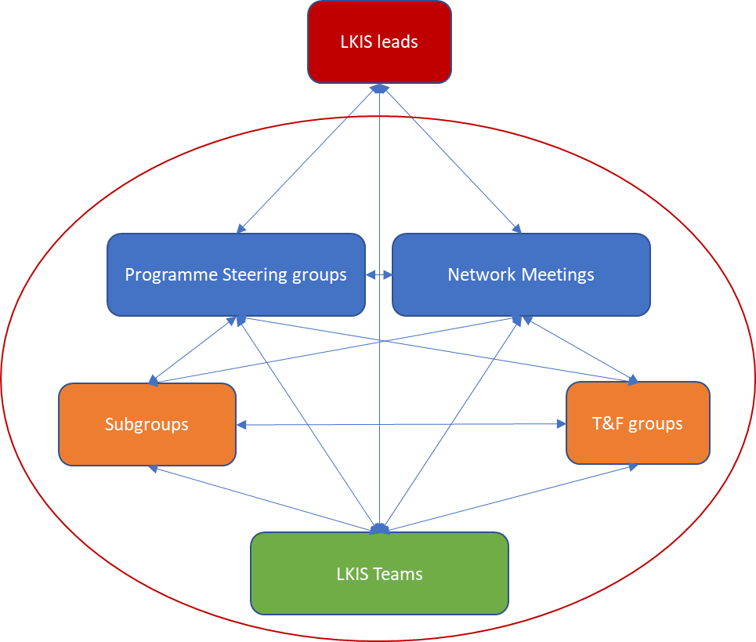
Figure 1. Modified after Matt Hennessey, 2021, “LKIS Network review discussion paper 6”, this diagram illustrates the number of relationships required in delivering the work programme. When one considers that there are seven LKIS teams, three Networks, numerous other groups, the number of relationships/dialogs that need to be maintained can exceed 250.

1. Systems Analysis: Current Ways of Working
In response to the LKIS Challenge, a systems analysis of the LKIS ‘ways of working’ was initiated through the delivery of a systems workshop for the LKIS Leads and the uG7 Programme managers (4 May 2021), at the request of LKIS Leads (Appendix A).
- A very brief workshop (90 min) set out to identify the drivers of the LKIS workload and the barriers to improving the workflow.
- In the next two sections ‘Function not Structure’ and ‘Simplifying Structure’, I set out a set two insights that I extracted from the systems workshop and developed in the context of programme management needs for the South West.
- A final section on the ‘Future Role of Regional Teams’ describes how, as a consequence of a planned (1) reduction in resources, (2) increased workload due to ICS support, and (3) streamlined project management, the focus of regional team efforts could usefully change.

Improving workflow: Focussing on Function
I created an ‘influence diagram’ based on our discussions to illustrate some of the challenges we identified in our current workflow that is in part created by our organisational structure (Appendix A). I have simplified this into a more recognisable project workflow with the four identified elements of our current structure (Fig 2). I’m suggesting that project management take the lead in processing workflow; the intelligence process and networks deliver into that process and programme and organisational management lead operational and strategic activities, respectively.
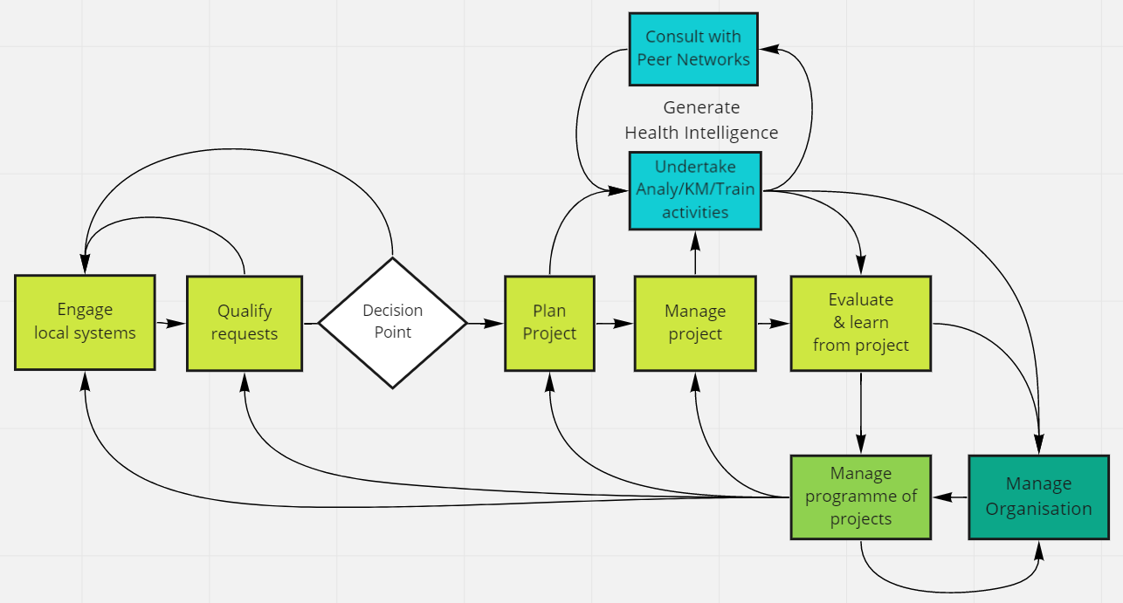
Figure 2. Four functions (Project, Programme, and Organisational management and health intelligence) are required to deliver a single cohesive LKIS delivery and capability development process.
- Organisational management: Leadership -- strategy, vision, direction, big-picture understanding.
- Programme management: Operations – resource allocation and programmes assurance.
- Project management: Nuts-and-bolts. Move projects and BaU workflow through their life-cycle.
- Health Intelligence: Why we exist. Deliver intelligence and continuously improve capability.

Simplifying Structure
Organisational structure representing the current situation or view (Fig 3, Top) and an alternative structure (Fig 3, Bottom) representing a high-level functionally based structure illustrates how we might simplify relationships and a clearly identify a crisp decision-making point for project workflow.
I think that it is useful when the purpose of the organisation is clear from our structure. There are two functional loops: (1) Continuously improve the ability of LKIS, as an organisation, to deliver and to improve health intelligence for the system and (2) Deliver continually improving health intelligence. This is high-level.
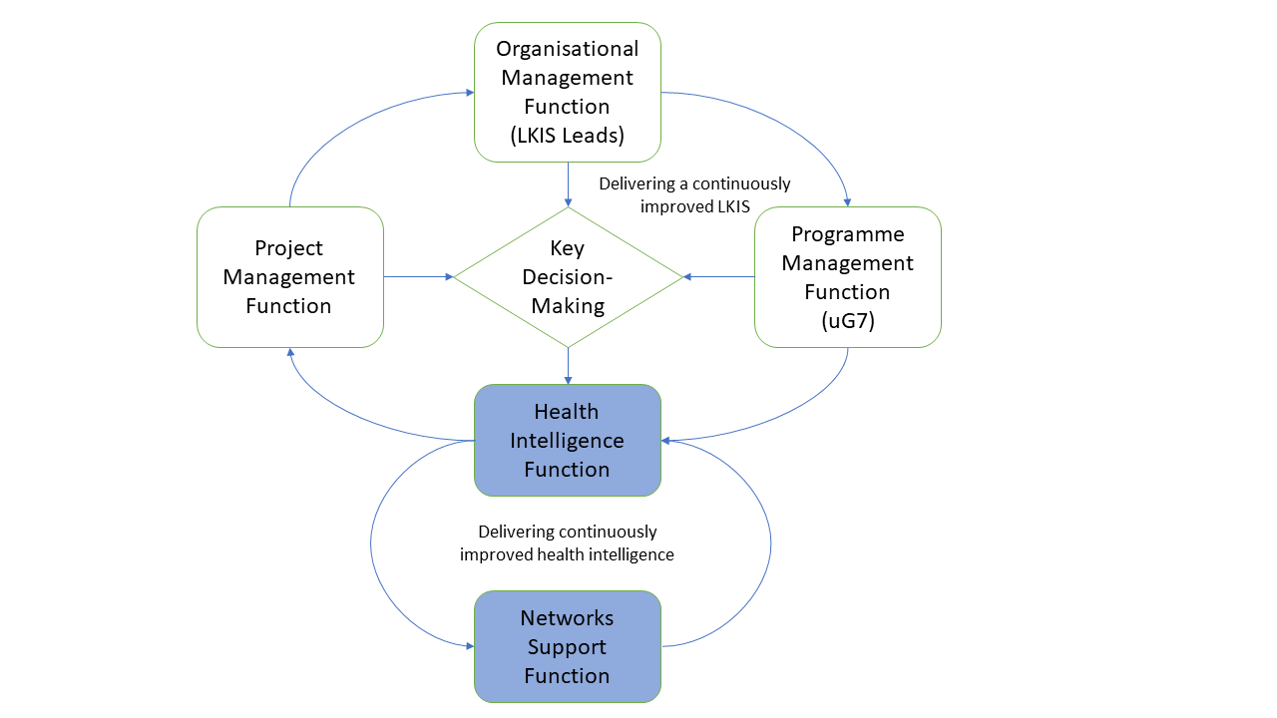

Figure 3. If we move away from a structure dominated by administratively defined groups, and instead represent organisational structure in terms of functional groupings and their purpose, we can see that LKIS has two complementary goals: Improve LKIS as an organisation and Improve health intelligence.

Future Role of Regional Teams
We didn’t talk much about regional teams at the workshop, except to repeat the original point that there is tension in trying to balance work programme needs across teams and LKIS, as a whole.
What follows are some thoughts arising from our current situation:
- Planned staff reduction (Fig 4)
- Potentially increased workload if we meaningfully engage with ICSs (Fig 5)
- An opportunity to strength LKIS problem-solving capability with systems and futures thinking that might attract more resources.
As Matthew Hennessey has identified, having seven LKIS Teams contributes considerable complexity to our health intelligence system. These are small teams (much smaller than my Public Health Dorset team) and each Team is now diverting some of our limited resources into the development of apprentices.

Staff Numbers
The structure of the Covid-19 funded recruitment illustrates a planned reduction in staff starting from the end of 2021 (Fig 4). It is possible that we will lose all of our project management support by April 2022. Therefore, I believe their contribution needs to be to implement systems that can be managed be remaining staff, past that point, not in managing specific projects. The role of LKIS Teams should be to manage the entry point, engagement with local systems, of the project workflow.

Figure 4. The staffing projection for LKIS is currently one of ‘planned decline’ from the current strength of around 100 people to some ~30-40 in 2024. Our function, capabilities and structure will be, in part, determined by our size and the current plan sees an LKIS of only 1/3rd its current strength.

One Team: Seven Doors
If the current LKIS strategy (even if the default situation is a ‘no strategy situation’ due to the circumstances of pandemic funding) leads us back to very small regional teams and LKIS towards a total of 36-42 WTEs, then we need to ask whether seven regional teams ‘undertaking independent health intelligence projects’ is a viable structure.
An alternative model would be to function as a single team (i.e. no independent regional projects – ‘do once for all’ is the default), with seven doors or ‘entry points’ for local system workflows.
Each regional ‘door’ would provide local system engagement on (1) the qualification of health intelligence required, (2) evaluation and monitoring to ensure we are making a difference and (3) knowledge to action support into local systems from national programmes. The actual health intelligence deliverables would probably need to be delivered by a single pooled national LKIS intelligence function (which could of course be physically distributed regionally, as it is now).
LKIS stakeholder engagement is likely to increase, because not only will we be dealing with local public health intelligence and colleagues, but we will also have to work out how to engage with the much larger intelligence effort that will emerge from the Integrated Care Systems’ Population Health Management programmes. More players, more complex relationships at the local level, ever changing priorities will require LKIS to pay more attention to the engagement of stakeholders (Fig 5).
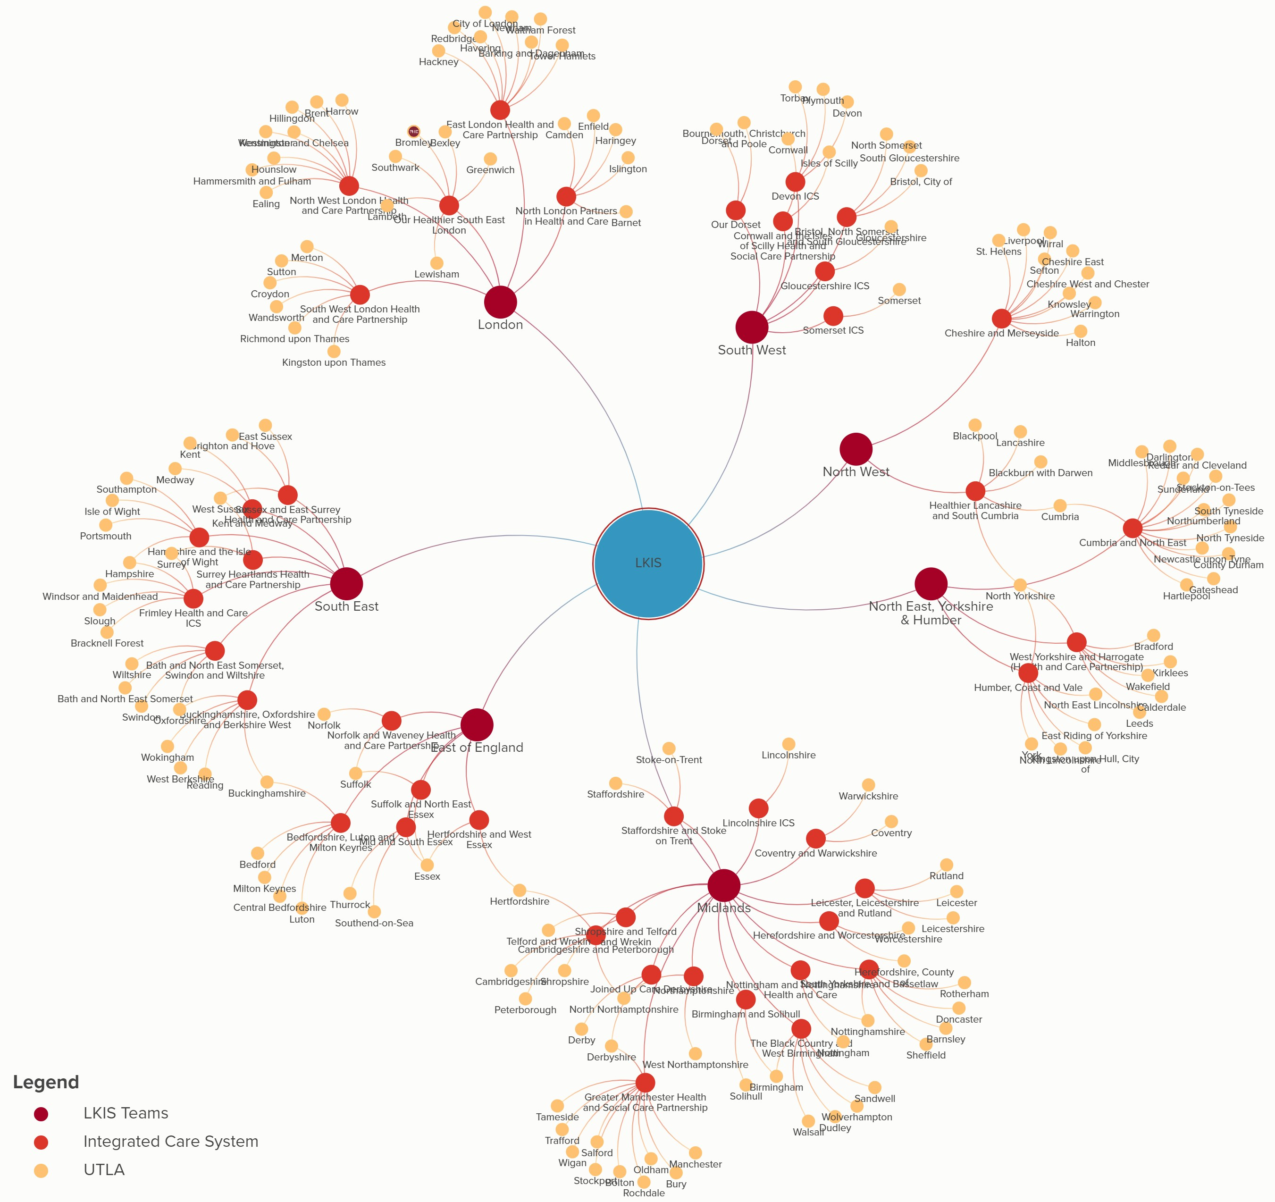
Figure 5. LKIS stakeholder map demonstrates the distribution of local systems, and the potential workload involved in engaging with Integrated Care Systems and their respective local authority based public health functions.

Rethinking our Relationship with Local Public Health Intelligence
I think that that the ‘local public health intelligence landscape’ will change quite a bit in some of our Integrated Care Systems. Some thoughts, leading to the next section on Systems and Futures Thinking:
- If LKIS is going to be a small group of 36-42 WTEs, and
- If it makes sense for Regional LKIS Teams to focus engagement and qualification; then,
- We need to view ‘local public health intelligence’ as being inside ‘our’ health intelligence system, which means rapid adoption of co-design and co-production approaches to develop future intelligence and insight, and
- This opens the possibility that Regional LKIS Teams could become the leads in using and building capacity in Systems and Futures Thinking.
We might call this approach a ‘Whole System Intelligence Model’ (Fig 6). This is a conceptual model asking the question: what would our LKIS system look like if our 'intelligence system' included local public health intelligence?
Would this explicitly require LKIS to move to a co-design and co-production approach to intelligence, which would have flow on effects in terms of how we organise data and tool access? Its four separate loops are best read by hovering the mouse over the loop name in Kumu, so that only that loop is visible. Best to start reading this map from the BLUE elements. This is where the workflow should originate.
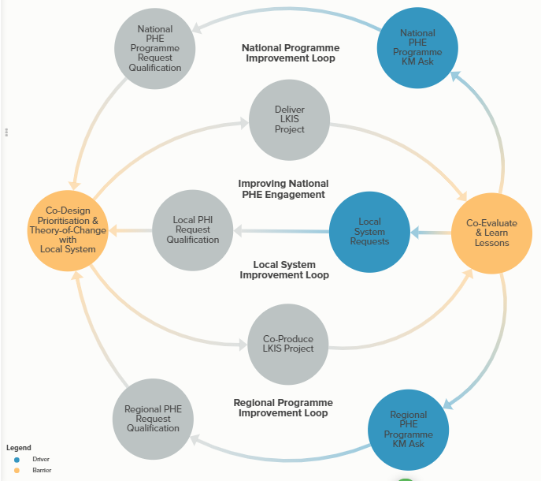
Figure 6. Whole of system LKIS approach might capture workflow from three sources, BLUE elements, with four clear processes we are trying to improve/develop and two important barriers to progress that would have to be proactively solved, ORANGE elements. The Kumu model allows each loop to be viewed separately.

2. Strengthening Health Intelligence: Future Ways of Working
It will seem counter-intuitive to talk about increasing the number of health intelligence approaches going forward when we have fewer resources. However, the data science approach to public health analyses will offer considerable scope for efficiency gains in our traditional analytical workload, while allowing Regional LKIS Teams to strengthen health intelligence by leading on Systems and Futures Thinking approaches.

Health Intelligence Challenge
From a public health intelligence perspective, it seems increasingly difficult to produce ‘intelligence and insights’ that are ‘actionable’ and are going to be seen to be actionable within Integrated Care Systems. However, from the wider public health situation, it also seems increasingly challenging to:
- Systematically apply evidenced-based intervention consistently
- Address variation that exists within our systems
- Establish longer-term plans and resist constant staff ‘churn’
- Provide wrap-around services and support for those most in need and who will cost the system the most
- Learn and implement, from other countries, primary care/community models
These intelligence and public health challenges are actually one and the same; they are just different perspectives on the same challenge – what is preventing us from being more effective?

What problem are we trying to solve?
This is key. The problem we are trying to solve for both public health intelligence and more broadly public health: Why is actionable insight so hard to develop and implement?
- Public Health Intelligence: What prevents us from providing intelligence and insight that ICS colleagues can immediately action in order to improve service delivery and ultimately improve population health and reduce health inequalities?
- Public Health: Why is it so hard to use existing evidence to implement system-wide disease prevention strategies that have the impact they were intended to have?
A large part of the answer to this problem lies within the domain of ‘systems science’ and the realisation that disease causation & by extension prevention, and public health systems, are complex. There are no silver bullets left.

Population Health and Complexity
If we are to improve the effectiveness of actionable intelligence/insight and our resulting public health interventions, we need to do two things:
- Recognise Complexity within our Systems: Our current public health intelligence paradigm is predicated upon ‘analytical thinking’, which in turn is derived from the reductionist scientific approach to problem solving. Reductionism has been very effective in helping solve many scientific problems, but it has shown itself to be of less value when trying to understand human dominated systems, such as our health and care systems.
- Adopt our approach to Problem Solving: We need to supplement our ‘analytical thinking’ with a ‘systems thinking’ process and we need to also supplement the ‘intelligence as service’ business model that we currently use to implement the analytical thinking paradigm.

Analytical Thinking (Dominant Paradigm)
The term ‘analytical thinking’ was coined by the organisational theorist, Russel Ackoff, and it describes the paradigm by which we attempt to solve problems in organisations. We respond to intelligence challenges using ‘analytical thinking’:
- We collect/capture data and describe relevant events, e.g. CVD deaths
- We attempt to understand what is happening by reducing these events to their component parts, e.g. by sex, age, risk factor, location, etc.
- We explore event patterns to provide a better understanding of relationships between outcomes and risks (e.g. regression modelling) (Fig 7)
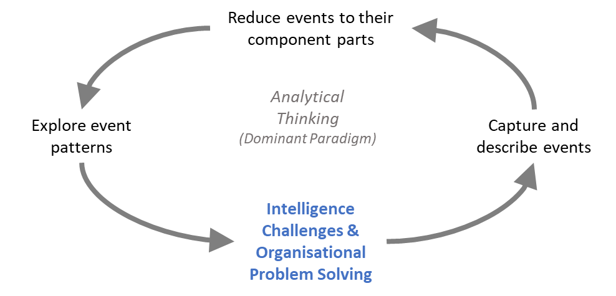
Figure 7. Analytical thinking, the dominant health intelligence paradigm, operates (at a high-level) to solve-problems and provide insight by breaking down ‘events’, e.g. registered Covid-19 deaths, into ever smaller parts, e.g. by sex, age, SES, before attempting to reconstruct a broader pattern.
This process is the dominant paradigm in health intelligence, and it has served us well for many decades. However, we also know that working with clients to identify the ‘intelligence challenge’ and any underlying questions is often a long iterative process. It is often unsatisfying because the ‘client’ often does not want to invest a lot of their time – ‘they just want the data’.
However, our ‘single minded approach’ to health intelligence is largely responsible for the difficulties we experience in effectively engaging with clients – there appears to be only one way to support decision-making and that’s through Analytical Thinking (Fig 8).
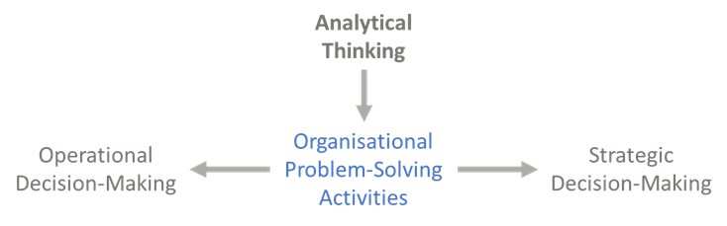
Figure 8. Analytical thinking, while increasingly powerful through the adoption of data science methods, nonetheless provides a single approach to organisational problem-solving and the support of decision-making.
The domination of the Analytical Thinking over any other type of approach to problem-solving didn’t happen by accident, it is a product of the very successful reductionist scientific approach (Fig 9). The problem we now have, and most analysts sense this, is that what worked well for understanding diseases, viruses and the like, doesn’t quite deliver the same understanding when applied to health systems where human decision-making, organisational culture and complex inter-organisational structures create complexity and dynamics/behaviours. This is our ‘problem-solving’ space.
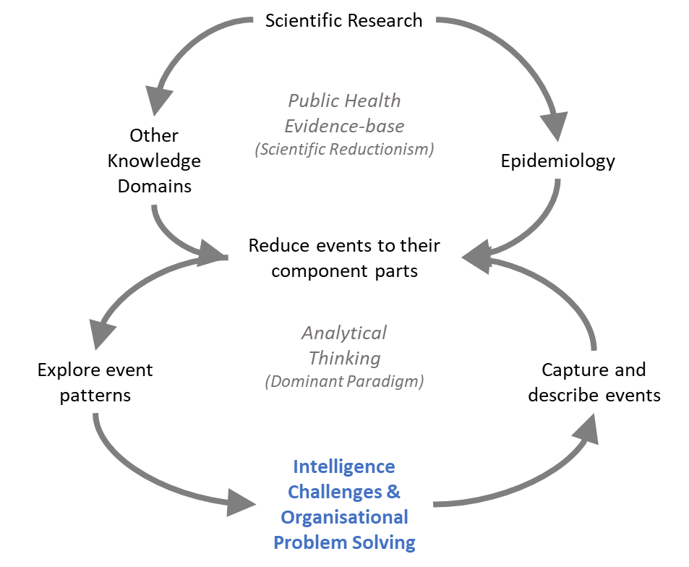
Figure 9. Analytical thinking is driven by the same reductionist processes that are at the heart of most scientific research. This approach to problem-solving has been hugely successful delivering the ‘public health evidence-base’, but it is limited in what it can explain about the functioning of systems that include human behaviour, e.g. health systems.

Systems Thinking
The term ‘systems thinking’ originates with Jay Forrester and has had numerous subsequent proponents including Donella Meadows and Peter Senge. Systems thinking provides a complementary approach to analytical thinking:
- In this approach, we focus on developing a ‘shared-understanding’ of the challenge. This involves exploring the mental models that, to an extent, shape how we see the world. It’s an exploration of ‘what people really think’ about a particular challenge/problem.
- We attempt to combine these ‘qualitative data’ into a visual map of the system. Specifically, we want to capture the key elements of interest, their relationships and most importantly identify ‘causal pathways’. The allows explanations of why things happen.
- We explore the structure of the system, as mapped, and if at all possible, to seek to a better understanding of the dynamics/behaviour that emerge from that system structure.
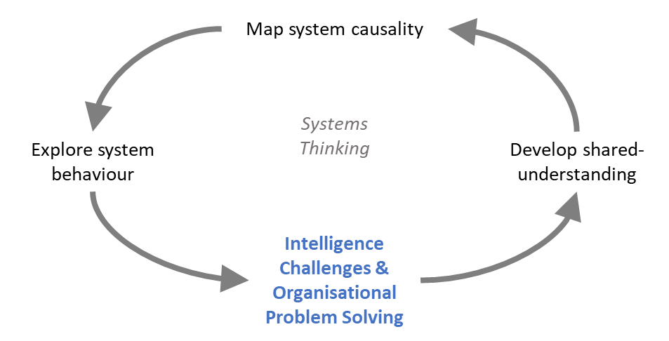
Figure 10. Systems thinking seeks to explain why things happen, as opposed to analytical thinking, which focuses on constructing knowledge about what, when, where something is happening. The starting point for a systems inquiry is the question, what is this a part of? Understanding relationships that represent system causality allows for the further exploration of system behaviour.
This approach is completely different to analytical thinking, because it does not seek understanding through a ‘reductionist scientific method’, but rather looks at challenges and problems as components of a wider system. This approach to problem solving seeks to understand the ‘whole system’ (cf. case study Appendices C, F and H). It is necessarily qualitative (or ‘soft’) when exploring what people think about the problem (often termed their hidden mental model).
System dynamics modelling, attempts to capture the developed shared-understanding of system structure in order to simulate the resulting dynamics of the system, potentially leading to greater knowledge about the system and enabling group learning. System modelling connects analytical thinking to the users of health intelligence in a useful way (cf. case study Appendices B, D, E, G). It allows them to explore the dynamics of quantitative knowledge in specific settings, eg. an ICS..

Futures Thinking
The term ‘futures thinking’ (also known as futurology or strategic foresight) probably originates within the academic disciplines of history and sociology, and later in engineering/technology, but it was popularised by the emergence of science fiction and writers such as Jules Verne and H.G. Wells. During the 1960s Futures Thinking took on more familiar methods from pioneers like the RAND Corporation, an work by Donella Meadows (notable Systems Thinker) on the Limits to Growth, and the Toffler’s Future Shock. Since then there has emerged a number of professional ‘futuring societies’ and university ‘futuring’ degrees.
The Government Office for Science (GoS) is responsible for central government futures thinking, but there are a number of examples of futures thinking around population health and health improvement in Public Health Dorset and from the UNFCCC (cf. case study Appendices J-L).
- We focus on scanning the horizon and attempting to identify what thought leaders everywhere think about the future, from their unique perspectives. This used to be an incredibly laborious task that resulted in most scanning reports being major, but infrequent, efforts to assemble knowledge at one point in time (cf. UK Government Foresight Projects). However, AI tools are becoming so advanced, that analysts can use them to regularly focus on developing relevant insights rather than gathering the thoughts of pundits (Appendix K).
- We use the gathered data about what is on the horizon to identify weak signals and trends that suggest emerging ideas about the future. The goal is to contextualise and frame these ideas so that one can begin describing ‘probable futures’.
- We explore these probable futures to better understand which are most desirable, from our perspective (something we should be aiming for!), which are undesirable (they could be a threat) in our view and those, which might just be termed ‘strange’ (futures that are hard to recognise or reconcile with what we currently understand).
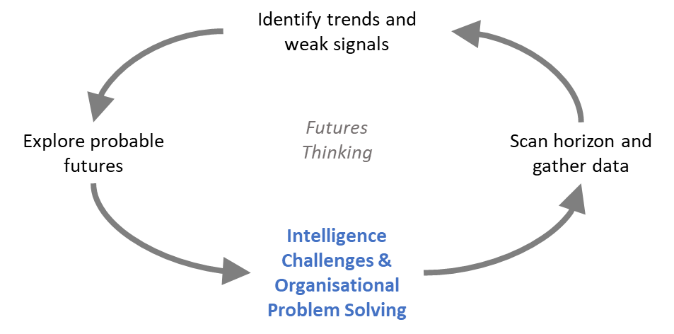
Figure 11. Futures thinking or Foresight processes seek to scan the horizon to identify trends and weak signals that can be explored through one of the many methods developed, including scenario development.

3. Integrated Approach: Analytical, Systems & Futures Thinking
It is not Analytical Thinking vs other approaches, but rather we need multiple approaches: Systems and futures thinking support and strengthen the analytical thinking approach and vice-versa (Fig 12).
- Systems thinking provides us with (1) a powerful new way of engaging clients, who are often unable or unwilling to take the time to help LKIS understand the problem they are trying to solve, and (2) it will improve our ability to provide actionable intelligence and insights.
- Futures thinking provides us with a way of connecting our shared-understanding of what is happening now with a more comprehensive approach to the question – what will happen next? This will be increasingly important contextualisation as we become increasingly reliant on data science forecasting methods.
- Analytical thinking will remain our core method of developing knowledge about our population’s health and the operation of healthcare services, but without support from systems and futures thinking approaches, we are likely to find it more difficult to focus on trying to answer the right questions and use knowledge effectively in organisational problem-solving.
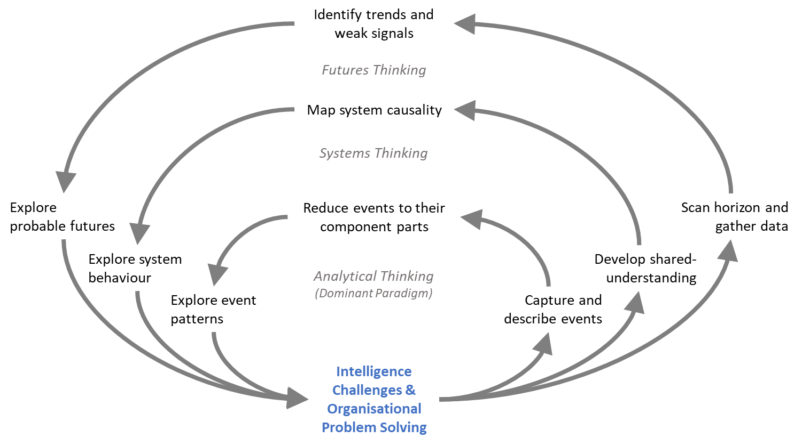
Figure 12. Adding systems and futures thinking into the intelligence repertoire effectively ‘deepens’ our organisational problem-solving capability, because the three approaches provide different types of insight that can be triangulated to provide more confidence to decision-making processes.
I believe that an ‘integrated approach’ will strengthen the health intelligence and insight that we deliver and facilitate knowledge to action processes. I would characterise this as ‘adding depth’ to what we already have (Fig 13):
- Systems and futures thinking complement and support analytical thinking
- Co-design and co-production approaches to ‘ways of working’ are fundamental to both systems and futures thinking and seem to be an attractive option
- Evaluation and monitoring have already been identified by LKIS as an important cross-cutting activity to be pursued and this feeds directly into the systems thinking approach
- Strategic planning activities by LKIS Leads would also support the futures thinking approach, which in turn would support organisational problem-solving in the longer-term
- All the above are useful tools in programme and organisational management, because they provide explanations of our organisations and systems behaviours that can help us to be more effective
- Political visioning (big and small ‘p’) determines the scope of permissible programmes of work – this is a civil service reality. We don’t talk about it, but all staff would be better equipped if staff across LKIS had a shared-understanding of why we put our efforts into particular areas and not others. Again, systems and futures thinking can help us to construct narratives and understanding about organisational goals.

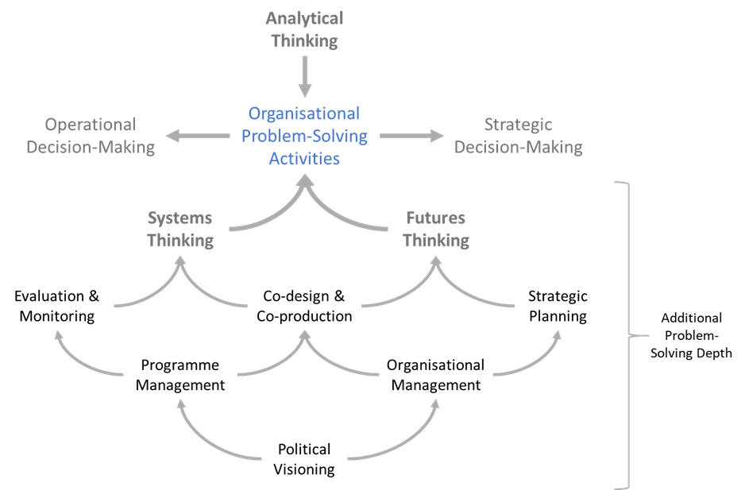
Figure 13. Adding systems and futures thinking approaches into organisational problem-solving adds depth, because it inherently connect evaluation & monitoring, co-design & co-production, and strategic planning into these additional health intelligence activities, which in turn draws programme and organisational management activities more directly into the production of health intelligence.

Another way of looking at this integrated approach to problem solving is to view it through Edward Hall’s Iceberg Model (Fig 14). This illustrates how these three approaches to problem-solving allow us to see ‘different’ aspects of the same system:
- Analytical thinking – sees events and with effort allows us to understand patterns in data
- Systems thinking – sees structure and behaviour of problems and allows us to understand the hidden mental models we all hold and that shape our world view
- Futures thinking – sees possibilities on the ‘horizon’ and seeks to understand how probable futures will impact us, so that we can steer a course towards our most desirable futures
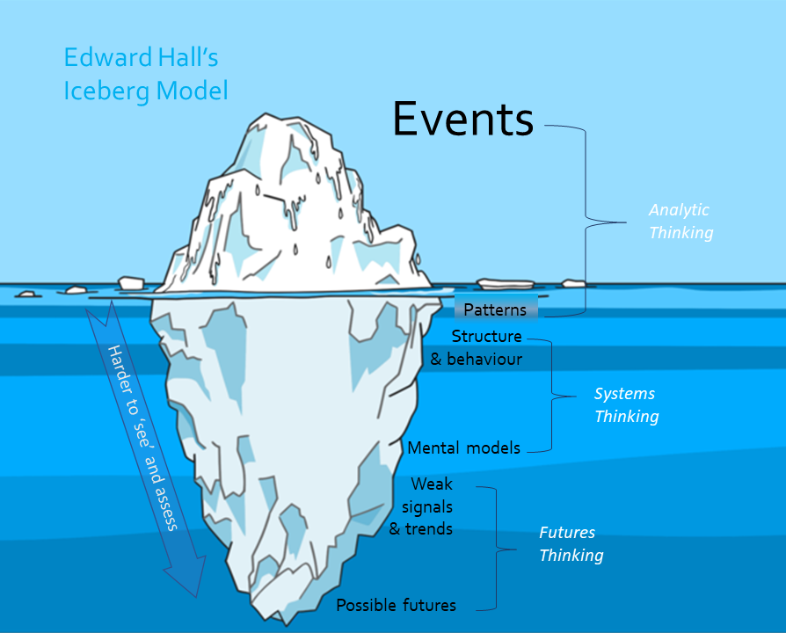
Figure 14. The Iceberg Model is often used to describe the visibility of organisational challenges, but it can be applied to health intelligence and/or organisational problem-solving challenges. In this application, I suggest that understanding how causality operates in systems and how these may evolve in the future are harder problems ‘to see’ and require different types of thinking to understand.

Supplementing the Current Business Model
The current LKIS business model can be characterised as providing ‘intelligence as a service’, where the client specifies what intelligence and insight they require (rarely easy or straightforward) and an intelligence product is developed and shared with the client, and others in the system. This approach, like analytical thinking itself is useful when data or information are all that is required to provide actionable insight. Unfortunately, as discussed above, that is often no longer the case.
For those situations where it is not obvious what the actional insight might look like nor how it would be usefully applied in a particular local system setting, we need to look at a different type of business model that could be termed ‘intelligence-led consulting’. This involves two changes in LKIS behaviour:
- Implementing a ‘client-centred approach’ to intelligence: This approach requires the traditional provider of intelligence to move from being a ‘service provider’, i.e. doing all the work, to a facilitator of a problem-solving process. We don’t have to develop the processes from scratch, as it is already well understood and articulated, c.f. Cockman et al. 1999.
- Redefining the provider-client split: We are all, public health intelligence and the wider health community we support, working towards the same aim. Improving population health. So why are all still standing in separate silos? It makes some sense if one group is tasked with collecting data, processing it, and developing a dashboard to share it, but it doesn’t make so much sense if we reframe what we are trying to do as ‘problem solving’. Systems thinking is about developing shared-understanding of what drives poor outcomes and what barriers might exist to implementing solutions within our local health and care system. If we can acknowledge that population health and healthcare systems are complex; then it makes sense to abandon traditional silos, come together, and combine the widest range of competencies towards collective problem-solving.
Client-centred consulting provides details on the processes and behaviours required to be effective in co-design and co-production, and
Developing shared-understanding will enable better solutions, and better shared-understanding of the much needed ‘actionable insight’ that will help us to better target our substantial analytical resources.

Knowledge to Action Impact
If we were able to add systems and future thinking to our existing analytical thinking approach, we would essentially have created a purpose specific knowledge-to-action method. Our theory-of-change might suggest that in addition to the intelligence & insights delivered using analytical thinking, we also provide systems and futures thinking (Fig 15).
Three outcomes seem self-evident: (1) we would provide deeper insight in challenges as well as improving the shared-understanding across the local systems, (2) this would lead to better use of intelligence and insights, and (3) eventually it would increase local system intervention success.
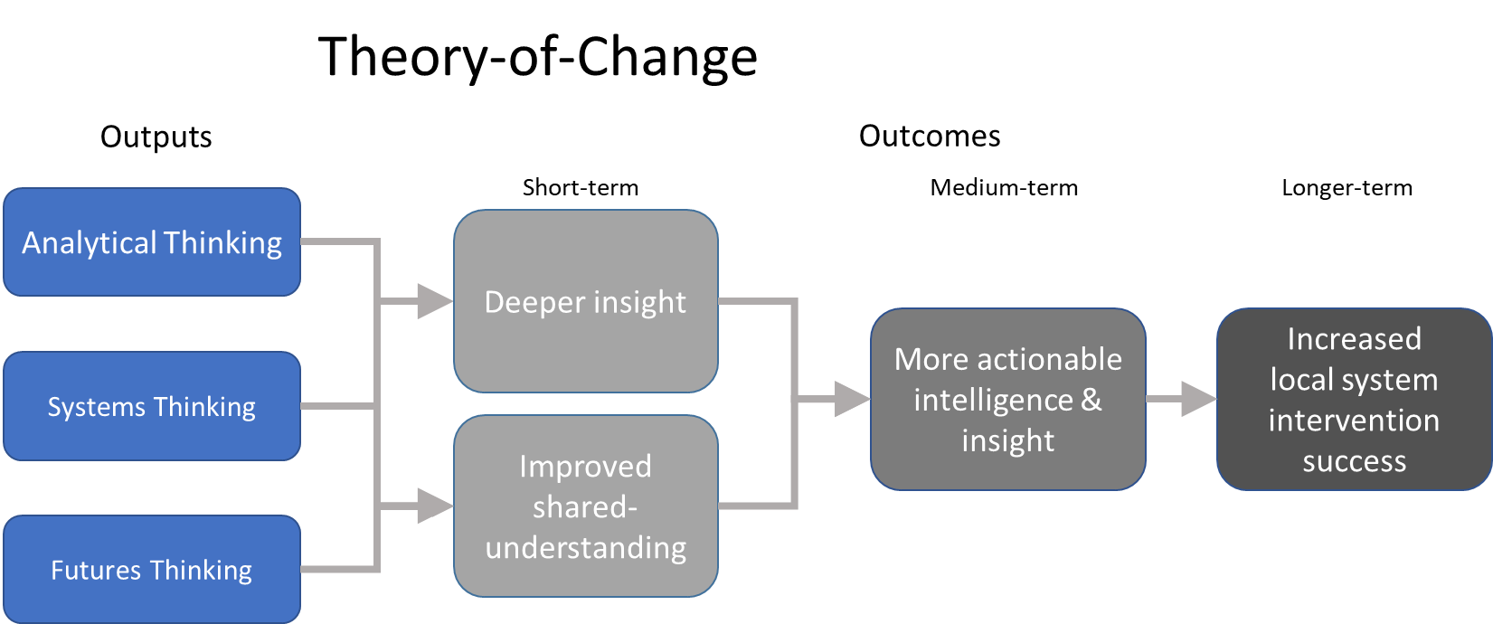
Figure 15. The theory-of-change for deepening health intelligence by adding Systems and Futures thinking.

Process Implementation
The systems and futures thinking approaches sit well within the KM domain, not the least for their already well-established relationship with our analytical colleagues. Although, training, would also be a key component in making a success of this implementation (Appendix I).
The Double Diamond design process is already well used and provides a common methodological framework from which to embed new process development (Fig 16).
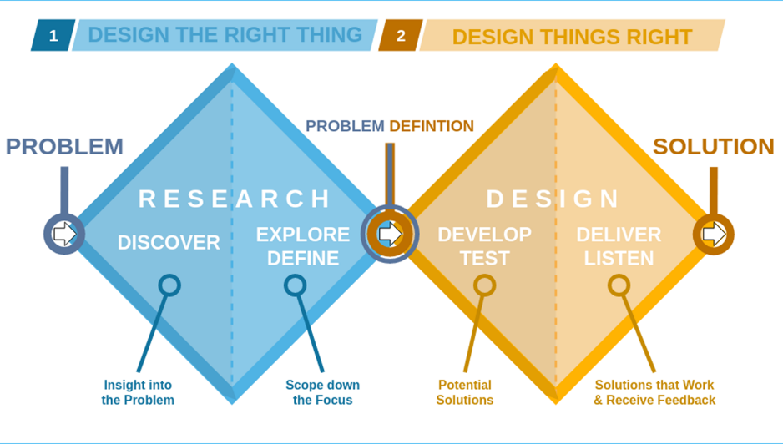
Figure 16. Double diamond ‘design process’ is a reliable and scalable approach to organisational problem-solving through which health intelligence approaches can contribute (Source https://commons.wikimedia.org/wiki /File:Double_diamond.png#/media/File:Double_diamond.png).
For example, implementing the systems thinking approach as a pair of workshops in the Research Phase, below, leads to a Design Phase, that uses identified leverage points and allows for relevant incorporation of systems dynamic modelling, where required (Fig 17).
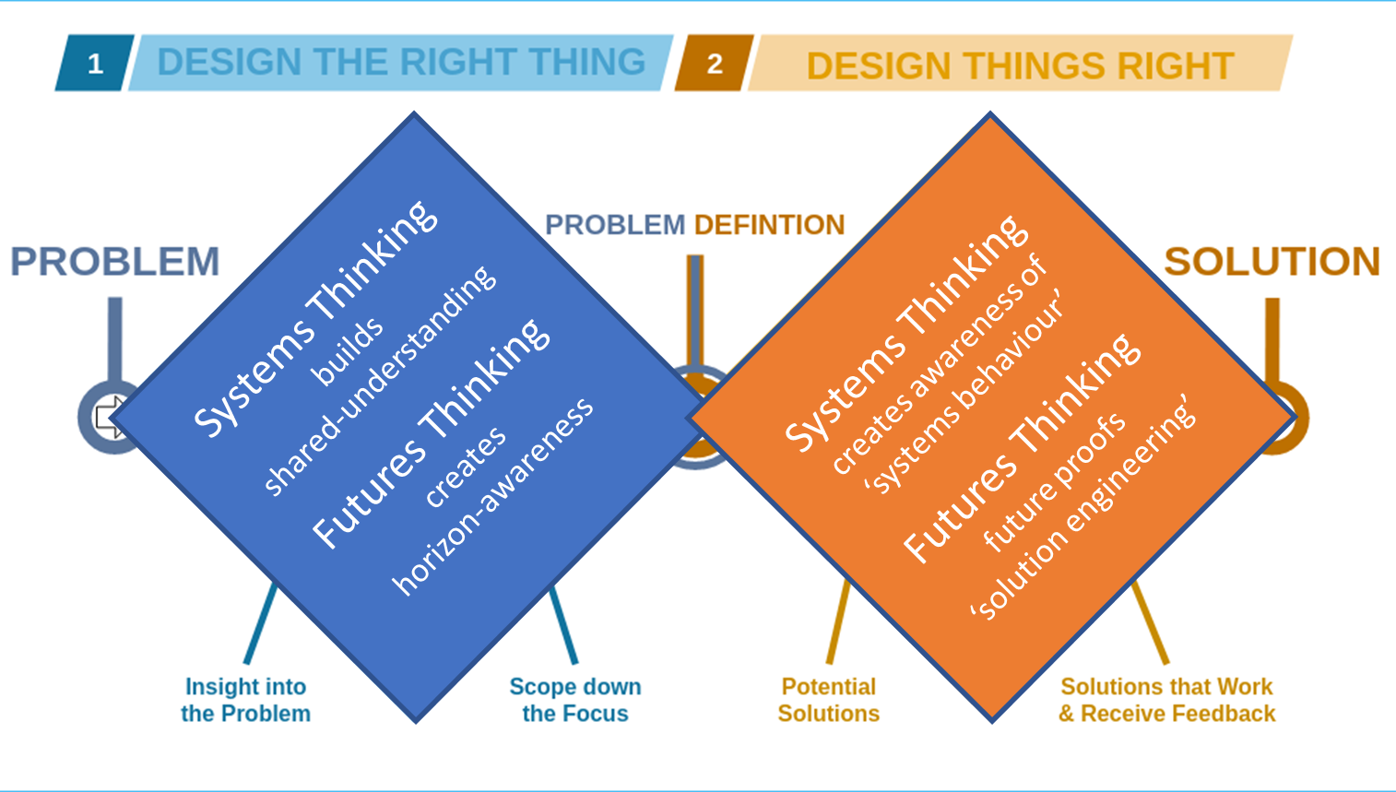
Figure 17. Inserting systems and futures thinking approaches into both the research and design phases of the Double Diamond process, complements the input traditionally received from analytical thinking (after https://commons.wikimedia.org/wiki/File:Double_diamond.png# /media/File:Double_diamond.png).
- Systems thinking workshops: We already have the inhouse skill to run the necessary workshops and it will be straight forward to upskill KM staff to facilitate workshops with local health systems.
- Systems dynamic modelling: More technical than soft systems methods. We have a training course currently under development. The idea is to begin seeding knowledge across the regions, with a view to region-wide modelling teams that share skills and co-develop models for common challenges (Appendix I).
- Futures thinking: Horizon scanning is the initial activity that needs to be undertaken, and this requires a subscription to an AI futuring service, such as ShapingTomorro.com, as Public Health Dorset has done. As with soft systems methods, the approach can be readily learned, if the request time and effort are put into practice delivering futures insights.

Prioritising Implementation
“If I had only one hour to save the world, I would spend fifty-five minutes defining the problem, and only five minutes finding the solution” (commonly attributed to Albert Einstein).
It is a reality that very few clients of intelligence and insight wish to spend the time necessary to understand their healthcare system challenges. All too many of clients, particularly in senior management would prefer to move directly to solution finding.
Therefore, it is not going to be practical to implement this combined approach with all clients or for all projects. We must choose a good client, that is invested in seeing a process through to the end.

Proposed Pilot Project
We have an opportunity to both support the current CVD Prevention effort and use this to develop our methods and the overall approach, as I believe there is a PHE ‘client’ willing to participate and they are keen to integrate this with their local systems engagement on CVD Prevention.

Appendices
These appendices briefly describe a number of activities and deliverables in the areas of systems and futures thinking that are relevant to the work of LKIS and PHE. Some may be useful case studies.
- LKIS Ways of Working System Thinking Workshop
  - Insight: There are a lot of workload drivers are generated internally
- Systems Thinking Case Study – Covid-19 SEIR Modelling
  - Insight: Dorset system epicell used a system model to inform operational planning
- Systems Thinking Case Study – Covid-19 Social Network Modelling
  - Insight: Analysts can combine systems thinking and analytics to see new patterns
- Systems Thinking Case Study – CVD Prevention Modelling for K2A
  - Insight: Early engagements with PHE colleagues suggests it is a useful K2A approach
- Systems Thinking Case Study – Public Health Intervention Modelling K2A
  - Insight: It is surprisingly hard to achieve high intervention success rates
- Systems Thinking Case Study – Rethinking Local System JSNAs
  - Insight: Many colleagues are locked into annually reported health statistics mindset
- Systems Thinking Case Study – Impact of Climate Change on Older Persons
  - Insight: As the climate heats up in Dorset, winter cold stress will remain most deadly
- Systems Thinking Case Study – HUMI Structuring Trans-Disciplinary Research
  - Insight: Lack of microbial diversity in environment indicates population health risk
- Systems Thinking & Modelling Training
  - Insight: Training being developed can be delivered in five different courses
- Futures Thinking Case Study – Health Improvement through
  - Insight: Dorset health system leaders identify political alignment as key strategy
- Futures Thinking Case Study – Application of AI to Horizon Scanning
  - Insight: New AI tools redefine how analysts now approach horizon scanning
- Futures Thinking Case Study – Resilience Frontiers a new approach to K2A
  - Insight: UNFCCC sees futures thinking as ‘disruptive method’ in search for innovation

LKIS Ways of Working System Thinking Workshop
What? A group workshop to tease out LKIS workflow issues that may lead to better ways of working.
Why? We recognise that our structure and internal decision-making may be over complex.
So what? There are increasing demands, decreasing resources, and wish to use resources wisely.
Insights?
Drivers of the LKIS Work Programme: I’ve identified out what appears to be five clusters or types of drivers. This is a subjective assessment, based on listening to the conversations and interpreting the thoughts that everyone has contributed during the brainstorming session.
- LKIS internal behaviours, values and beliefs
- Perceived external client behaviours and events
- National programme/policy/political asks/wants/needs
- Regional PHE Centres
- Local Public Health Systems
Barriers to delivering the LKIS Work Programme: There appear to be three solid clusters and two standalone barriers that might be worth ‘unpacking’.
- Prioritisation, allocation and accessibility of resources (people, skills, data)
- Process inefficiencies
- Insufficient qualification of client need/want/ask
Standalone barriers (worthy of further discussion)
- Fear of failure
- Need for evidence of impact
Workshop: Miro Board (below)| Influence diagram
Associated: Stakeholder map | Whole system intel model | ICS Engagement ToC 2021
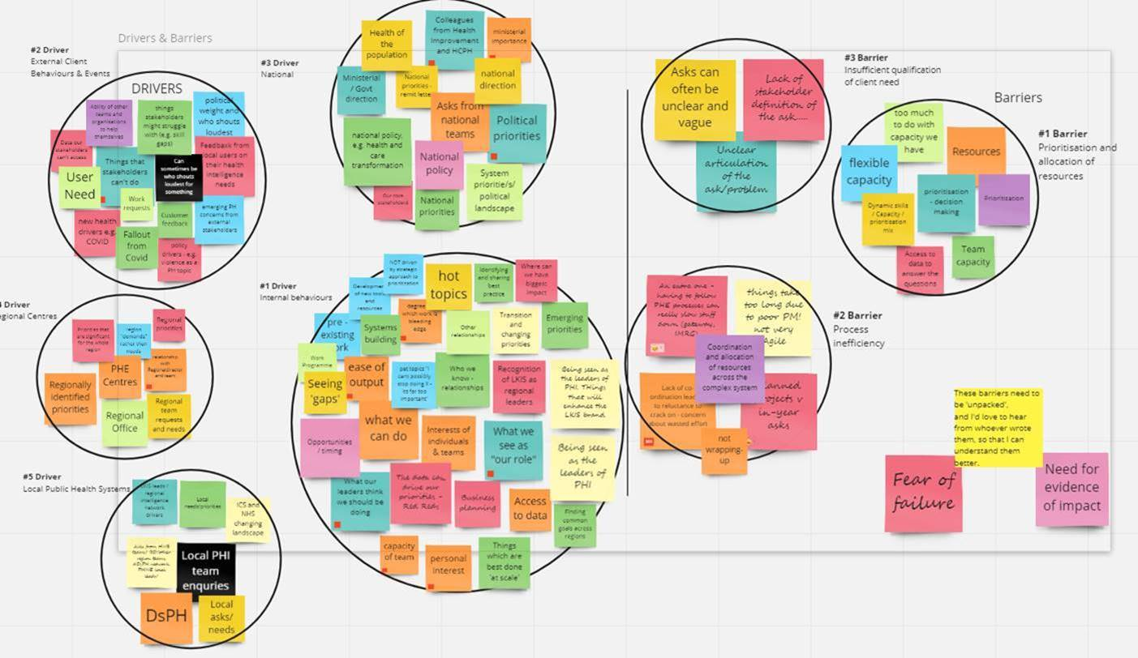

Systems Thinking Case Study – Covid-19 SEIR Modelling
What? In April 2020 Dorset Public Health built a systems model to capture what was known about SARS-CoV-2 community transmission, in order to be able to simulate the Dorset situation.
Why? There is very little epidemiological knowledge within the Dorset system, especially in infectious disease. We believe the model as a reservoir of what we know and understand about the nature of this disease, would be an engaging tool to develop a better shared-understanding.
So what? Knowledge to action. We will be conducting a post-hoc evaluation, but I feel that introducing this model into the Dorset ICS’s ‘Covid-19 epicell’ improved the quality of discussion, which in turn improved decision-making. This was our objective and we will attempt to evaluate this later in the year.
Insight? Providing colleagues with recent trend data (deaths, cases, hospitalisations) provoked the question – “so what will happen next?” Providing colleagues with a model projection provoked the question – “how do we know this is right?” The first response takes us to more data. The second response takes us straight into a conversation about the dynamics of Covid-19 in our community.
Infectious Disease Model Version 4.0
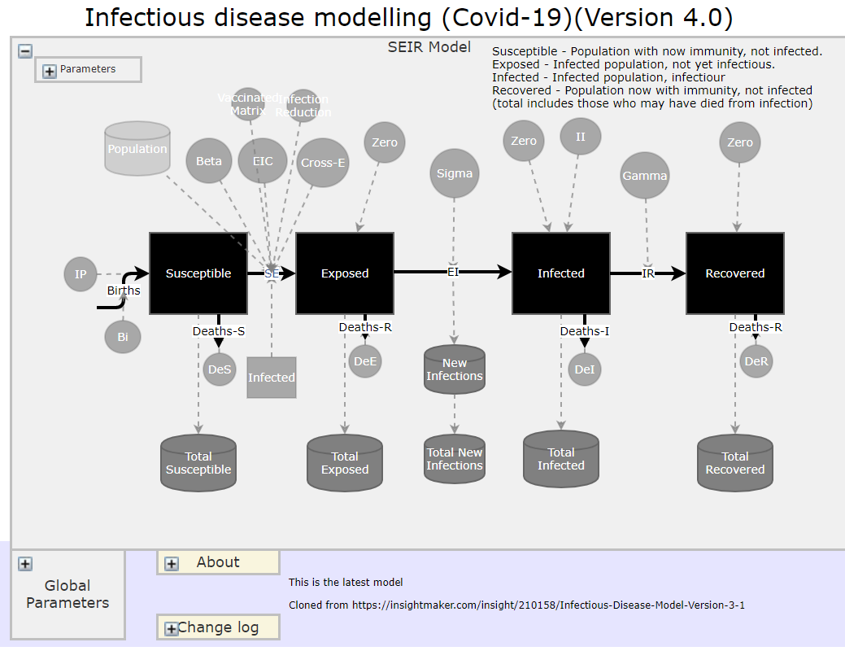

Systems Thinking Case Study – Covid-19 Social Network Modelling
What? Multi-dataset visualisation of potential transmission networks in the Dorset system using a Kumu.io. These visualisations are updated every day and processed using Python scripts.
Why? So that analysts could spend more time looking for insights and less time managing spreadsheets and other data sets in order to support local contact tracing and settings assessment.
So what? Reduces analyst time and cost, improves speed of data processing and aids insight development and sharing.
Insight? Even 10,000+ data elements and relationships can be explored in minutes in this form and it demonstrates how we can truly extract value from working more closely with Local Public Health Intelligence. PHE data sets, merged with local data sets and explored in KUMU.io after formatting. Almost all of this processing done without analyst intervention.
Covid-19 Transmission Network (No link as this is sensitive data, but demonstration of site possible with site owner permission).
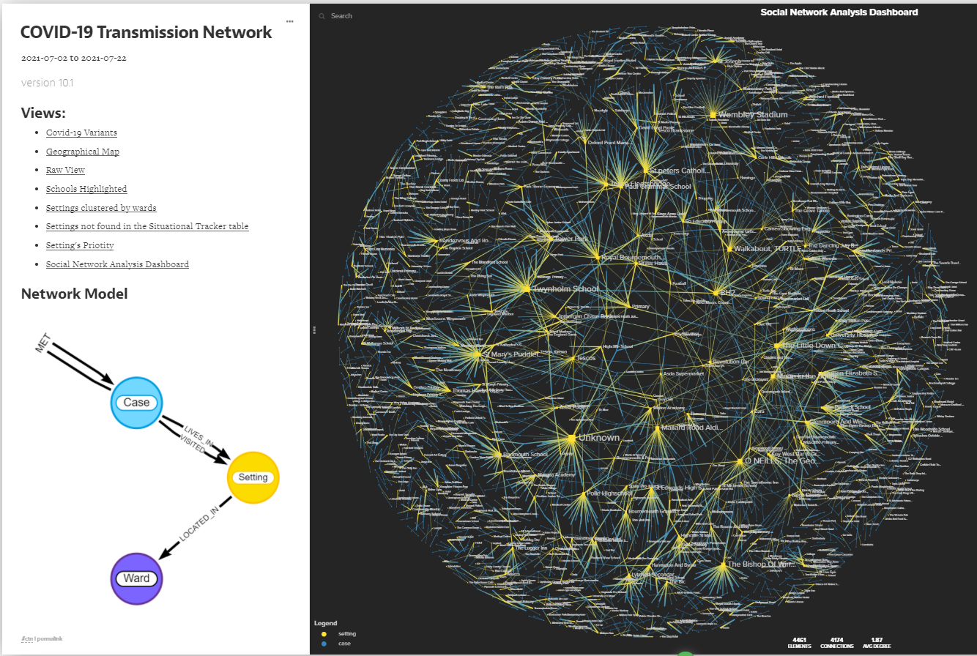

Systems Thinking Case Study – CVD Prevention Modelling for K2A
What? We have constructed a systems model to simulate the impact of CVD prevention in local systems to support PHE colleagues in their renewed push for greater knowledge to action.
Why? A systems model is a tool that can be used to capture knowledge and data into an interactive process of ‘what ifs’, that diverse groups of colleagues from an ICS can engage with each other to understand the behaviour of their local population and health system under various interventions.
So what? Knowledge to action. Systems thinking and modelling provides a coherent pathway towards more informed decision-making through which there is improved shared-understanding of the challenges across the ICS. This will be the model used in our system modelling training course.
Insight? Initial engagement with PHE staff in the CVD Prevention area indicates that they really appreciate what this type of modelling does and see a role for it within their programme.

CVD System Dynamics Model V1-1
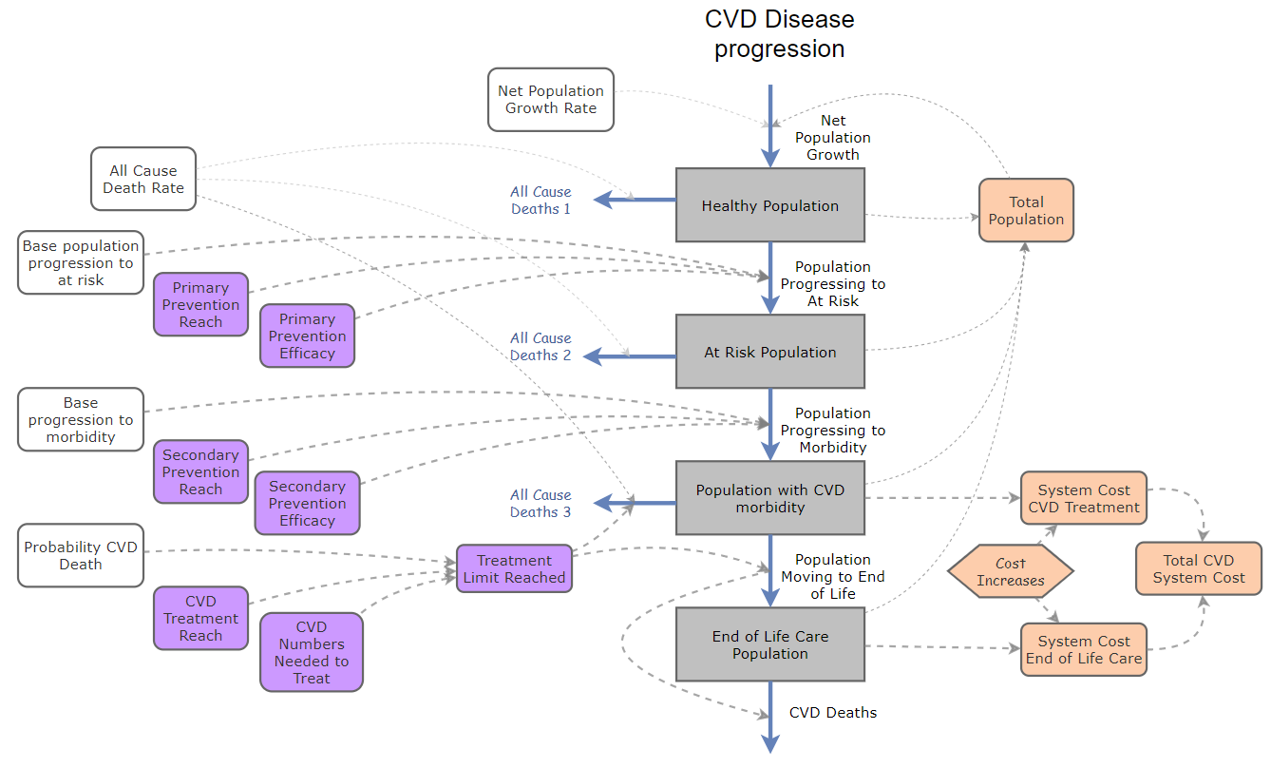

Systems Thinking Case Study – Public Health Intervention Modelling K2A
What? A generic intervention planning tool for public health colleagues. Captures the dynamics of any intervention based on three critical elements: intervention reach, intervention compliance and intervention efficacy. It allows local systems to tailor costs and population to their situation.
Why? There seems to be a wide-spread lack of appreciation amongst public health colleagues on the value of using these three elements in the management and evaluation of intervention programmes.
So what? Knowledge to action. If we want to improve public health interventions, we must develop a better shared-understanding of why some interventions are more successful than others.
Insight? High efficacy interventions do not necessarily make the best public health interventions. ‘Reach’ and ‘compliance’ are intervention elements that are determined by the health system and its users, and we need to actively incorporate this into our knowledge to action work.
Blog: Future of Public Health Intervention: Three Cold Hard Numbers
People are full of ideas, but how do we harness discussions about population health interventions and move them rapidly into real-world thinking and planning.

Intervention Planning Tool
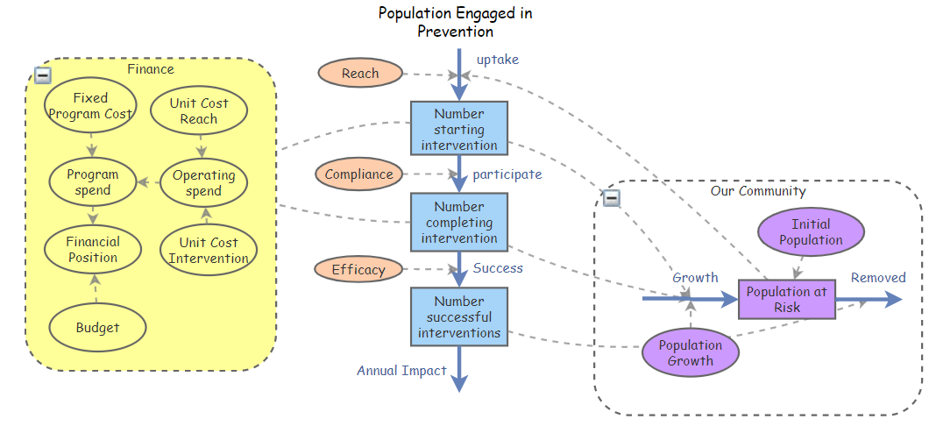

Systems Thinking Case Study – Rethinking Local System JSNAs
What? Routine data underpins the Public Health Dorset JSNA, as it does in many other Local Authorities. However, in Dorset their aim is to go one step further, to better understand local needs through combining ‘stats with stories’. They have developed insights based methods. One which will primarily support needs assessments (system insights) and another to develop their understanding of strategic issues and what might be done about them (people insights).
Why? Because it was felt (1) that one local systems are already drowning in data/indicators and (2) the idea that the JSNA was a ‘process’ through which local systems might invoke change was forgotten.
So what? Knowledge to action. Systems thinking has become the central health intelligence process in the Dorset JSNA and this is recognised by many groups and colleagues within the system as being ‘transformative’.
Insight? There is very little shared-understanding of what the JSNA process was meant to deliver to local health systems. For many colleagues its value will always be derived from having a statistical compendium of population health challenges at a specific point in time.

System Insights
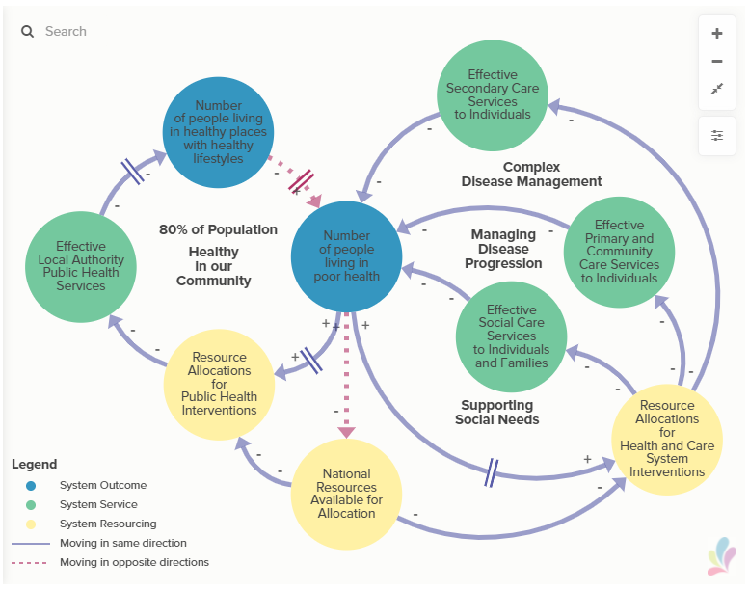

- Systems Thinking Case Study – Impact of Climate Change on Older Persons
What? An exploration of the future dynamics of temperature stress on the older population of Dorset using the Meteorological Office’s UKCP09 SRES A1B Emission Scenario Projections. This was a Big Lottery funded project through the Dorset Community Action group.
Why? To enable more realistic discussions amongst spatial planning staff and others within the Dorset system to be based on the best available data.
So what? The motivation was to bring together the best available climate forecasts for the region with regional information in order to provide realistic dynamic simulations of the problems.
Insight? That under current predictions, cold stress during winter was still going to be a bigger mortality problem (even though it will reduce) than warm stress mortality, which will increase significantly.

Temperature Stress Mortality Simulator V2.1
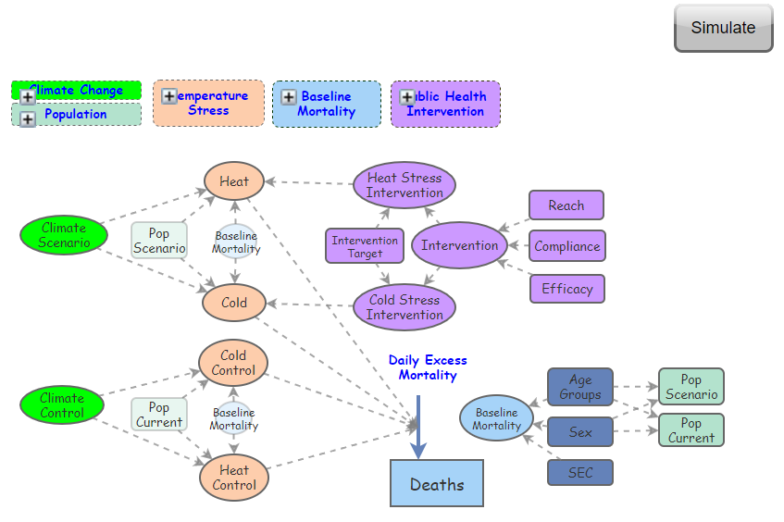

Systems Thinking Case Study – HUMI Structuring Trans-Disciplinary Research
What? A trans-disciplinary effort to understand the role of environmental microbiomes was initiated through a series of systems thinking workshops that resulted in a Health Urban Microbiome Initiative that is encapsulated in the ‘HUMI’ causal loop diagram.
Why? A number of instigating researchers (public health, restoration ecology and immunology) wanted to develop a large research effort around the idea that there urban populations were largely not exposed to ‘healthy urban microbiomes’ and therefore their rate of immune dysfunction was increasing rapidly around the globe.
So what? Futures thinking meets systems thinking. A large number of researchers, many internationally recognised for world class research, believe that emerging field of microbiome science will have a huge impact on public health thinking, particularly around health improvement through exposure to biodiverse green spaces that have healthy microbiomes that in turn could reduce population scale immune dysfunction and associated chronic disease.
Insight? Biodiversity loss, growth of urban populations and immune dysfunction are interlinked, and the loss of environmental microbial diversity may be responsible. Restoration of environmental microbiomes may improve populational health globally.

Healthy Urban Microbiome Initiative (HUMI)
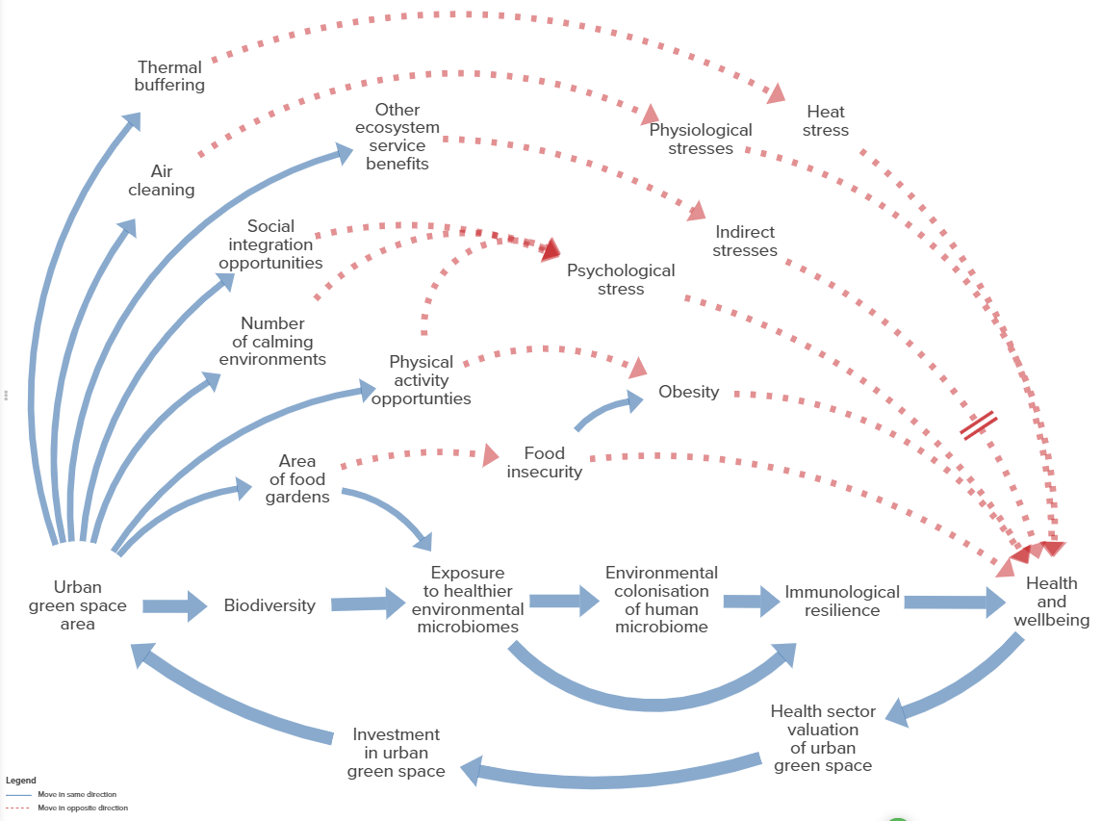

Systems Thinking & Modelling Training
What? Training development is underway for a short course on systems modelling. The system model that participants will develop as part of the training is the recently completed CVD prevention model, which will be used by colleagues taking the CVD Prevention Packs to Integrated Care Systems.
Why? The training is being developed in response to requests from the Local Authority Advisory Group (LAAG) run by South West LKIS. Planning for initially local training was initiated in 2019.
So what? Knowledge to action. We are seeing some appetite from local system colleagues, or at least their health intelligence staff, to develop modelling skills. We don’t at this point know where it will lead, but this could improve collective K2A capability.
Insight? We can deliver these eight modules in a number of ways to serve different training needs.
Module | Learning Objectives | Practical | Model
- Introduction to systems thinking for public health organisations  2-hour session | Course overview  - Participant requirements  - Why systems thinking approach, intent, deliverables and outcomes  - Why systems dynamics modelling, intent, deliverables and outcomes | Presentation Slides  - Kumu Demo: CVD Challenge  - Insight Maker Demo: Simple CVD SDM v2 | CVD SDM v2
- A soft systems approach for public health organisations*  2-hour session | Qualitative approach to developing shared-understanding of the structure of the challenge  - Problem definition | Presentation Slides  Demonstrate the two-workshop approach to mapping the challenge  - Miro Boards  - Kumu | No model used
- Systems Dynamics Modelling: an introduction  2-hour session | Understanding the basic elements as implemented in Insight Maker  - Stocks, flows, and variables  - Variable graphical user interface  - Implementing simple relationships  - Running models | Presentation Slides  Insight Maker | Participant created model
- System dynamics modelling for public health 1  2-hour session | Understanding a very simple CVD systems model  - Inputs  - Outputs  - Model structure/mechanics  Modifying model  - Replacing the intervention  - Adding a new output | Presentation Slides  Insight Maker | CVD SDM v1  - Single intervention  - Single outcome measure  - Limited or no internal code, beyond required equations
- System dynamics modelling for public health 2  2-hour session | Understanding a very simple CVD systems model  - Going one step further  Modifying model  - Replacing the intervention  - Adding a new output | Presentation Slides  Insight Maker | CVD SDM v2  - Multiple interventions  - Multiple outcome measures  Limited or no internal code, beyond required equations
- Understanding CVD prevention using system modelling  2-hour session | Understanding and using the CVD Prevention model  - Creating useful simulations  - Comparing simulations  - Understanding sensitivity analysis  Modifying model  - Replacing the intervention  - Adding a new output | Presentation Slides  Insight Maker | CVD SDM v2  - Multiple interventions  - Multiple outcome measures  - Limited or no internal code, beyond required equations
- Storytelling with InsightMaker  2-hour session | Using the built-in storytelling tools within InsightMaker to convey an understanding of a systems model. | Presentation Slides  Insight Maker | CVD SDM v2
- Building a learning organisation*  2-hour session | Introduction to this last module  Review of session learning  Process implementation  Lessons from the Dorset experience | Presentation Slides  Miro Boards
16 hours

Delivery Options
There are at least five ways in which we can deliver this material.
- Systems Thinking and Modelling for Organisational Learning: Modules 1-8 (16 hours)
- Introduction to system dynamics modelling in public health: Modules 3-6 (8 hours)
- A soft systems approach for public health organisations: Module 1 and 2 (4 hours)
- Systems Thinking for CVD Prevention: Modules 1 and 6 (4 hours)
- Systems Modelling for CVD prevention: Module 6 (2 hours)

Futures Thinking Case Study – Health Improvement through healthy places
What? Workshop with senior leaders from across the Dorset health system to identify strategies to take Dorset towards a future of ‘healthy places’
Why? Dorset is already seen as wonderful and beautiful landscape that people want to live, work and visit in. However, rarely to people from all walks of the health system consider its health giving potential.
So what? Environment is a key component of the ‘wider determinants of health. In the context of health improvement, Dorset’s health places can be viewed as health assets.
Insight? The highest ranked strategy for using Dorset’s ‘green’ assets for health improvement was to align population health priorities with political priorities.
The future of ‘healthy places’ — Developing futures strategies
Is it possible for a group of colleagues to get together, develop a vision of what we want our future to look like AND then actually develop strategies to work towards it?
Table 1. A subset of the top proposed strategies that senior leaders within the Dorset health system identified during a day-long workshop – a first introduction to futures thinking for the vast majority of participants.
Rank | Focus | Proposed  Strategy | Votes | Public Health Dorset  (as at Jan 2018)
1 | Political priorities | Find a way to align population health priorities with political priorities | 24 | - System working approach  - Narrative capacity building with BU Media Faculty
2 | Natural Environments | Maximise opportunities from natural environments in local spaces through eval-uating health impacts | 16 | - Healthy places programme  - System working approach  - Public health programme evaluation effort
3 | Active Travel | Increase focus on active travel opportunities as a key element of all travel planning | 13 | - System working approach  - Quantifying accessibility to greenspace project
4 | Volunteer resource | Older population is a rich source of skill and experience that could become a major volunteer resource | 12 | - System working approach  - Prevention at scale – aging well programme  - Locality working programme  - Health Champions Project
4 | Sustainable building strategy | Develop a sustainable building strategy (Healthy green developments in partnership) | 12 | - Healthy places programme  - Spatial planning development project  - System working approach

Futures Thinking Case Study – Application of AI to Horizon Scanning
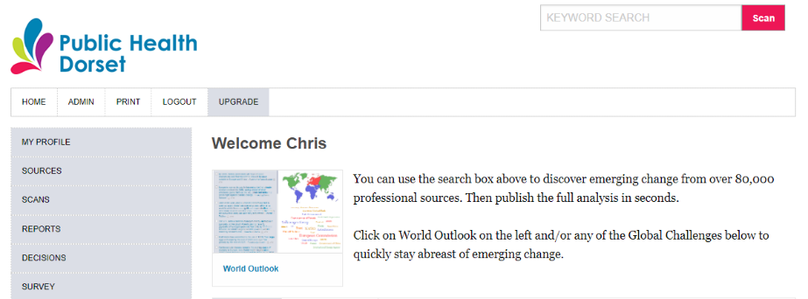
What? The use of ShapingTomorrow’s AI to scan the horizon has radically changed the process and effort required for organisations to identify trends and weak signals. Public Health Dorset created its own ShapingTomorrow website.
Why? There were a number of futures thinking projects that the analyst team felt would contribute to the intelligence and insight programme.
So what? With a relatively small team, it was impossible to dedicate the resources to horizon scanning that were needed to be able to produce regular reporting. With AI – horizon scanning is within reach.
Insights? Combining horizon scanning with AI and associated data analytics might be a game changer in terms of facilitating more meaningful futures thinking in organisations.

The Future of Healthy Places — a first glimpse…
Are you interested in working towards a future that has healthier places to live, work and learn? If you are, read on. We are using futures studies methods to envision what that future might look like, and my colleagues and I will use this blog to share our insights.
The future of Healthy Places -- Urban Greenspace
The first point to make is that research examining the relationship between proximity to well managed urban greenspace and good health is very consistent – green space in urban environments benefits a population’s health in multiple ways. Not just in urban environments, that’s what we are interested in here, but natural landscapes provide essential ecosystem services from catchment level through to global scale services. Nature is good. Many of us like to wander in green fields and forests when we get the chance – it makes us feel good. Most people get that, but there’s more.
Fake news. The future of public health messaging
Ever tagged a friend in one of those ‘too good to be true’ headlines? “Dark chocolate improves your eye sight” or “Sitting for 20 minutes less a day makes you more muscly”. These days this sort of enticing news is everywhere we look – and wouldn’t it be great if we could lose weight on an all chocolate diet (just me?)! But behind these attention-grabbing news stories lies a real risk to the future of public health messaging.
The future of ‘healthy places’ -- Global Warming and Population Aging
This is a ‘futures’ story about Global Warming and Population Aging, two global mega trends, and their likely impact Across Dorset, Bournemouth and Poole. We took a small peak into the future and this is what we saw.

Futures Thinking Case Study – Resilience Frontiers a new approach to K2A
What? The UNFCCC set up a new programme called Resilience Frontiers in 2019 with the express purpose to create “disruption” around how we think about the future of climate change adaptation.
Why? Time is running out. The climate emergency is upon us, climate mitigation is not working, and we will be unable to avoid major, maybe catastrophic climatic changes. New thinking is required.
So what? They have created eight pathways through which to focus thinking, innovation and the development of new adaptions strategies. Pathway 6. Optimising future health and wellbeing using a holistic and ecosystem approach [Pathway Lead is Dr Chris Skelly, UK]. This is health improvement.
Insight?
Songdo, South Korean futuring event that initiated the programme
Public Health Dorset blogs that I wrote setting out the approach taken at this event.
Resilience Frontiers: Day 1 — Probable Futures. I’m participating in a United Nations Framework Convention on Climate Change (UNFCCC) sponsored event in Song-do, South Korea this week. As part of a larger event on Adaptation to Climate Change, this Resilience Frontiers event, is a five day futuring…
Resilience Frontiers: Day 2 — Desired Futures. Sounds like a population health challenge! The day began with a restatement of the challenge involved in building resilience in the face of climate change; it will be a very familiar problem to those of you working in Public Health…
Resilience Frontiers: Day 3 — Strange Futures. “Never doubt that a small group of thoughtful, committed citizens can change the world; indeed, it’s the only thing that ever has.” Margret Mead Day 1 — Probable Futures — identify and describe what we think is most likely…
Resilience Frontiers: Day 4 — Group Moonshot. We had an incredibly long day today or so it seemed. Group work is exhausting, but satisfying when the discussions are interesting and complex. We followed the same process for making a Moonshot as we did on Day 2…
Resilience Frontiers: Day 5 — Conceiving Policy. Thoughts on the Week This was a long and often intense week — as only these types of events can be. The reality of actually gathering together 125 people from a variety of professional, cultural and demographic backgrounds…
Resilience Frontiers 2021-2030
Each of the eight RF Pathways are to chart their own way through the development of new ideas and the development of innovative adaption projects and strategies.

Modified after Matt Hennessey, 2021, LKIS Network review discussion paper 6.ppt
Cockman, Peter, Bill Evans and Peter Reynolds. Consulting for Real People: A Client-Centred Approach for Change Agents and Leaders. 1999. Second Edition. McGraw Hill, 292pp.

